Research Article

**Analysis of environmental effects and estimation of genetic parameters for carcass traits in Hanwoo steers produced through embryo transfer**

Du Won Sun1, Eun Ho Kim2, Hyeon Kwon Kim3, Il Keun Kong2, Jung Gyu Lee2, Hyun Tae Lim2*

1Gyeongnam Animal Science & Technology, Gyeongsang National University, Jinju 52828, Korea

2Department of Animal Science, Gyeongsang National University, Jinju 52828, Korea

3Poultry Research Institute, Rural Development Administration National Institute of Animal Science, Pyeongchang 25342, Korea

**\*Corresponding author:** s_htim@gnu.ac.kr

**ABSTRACT**

This study estimated the environmental effects and genetic parameters for carcass traits of 2,309 Hanwoo steers produced through Embryo Transfer (ET) to confirm the performance improvement achieved. The data used for analysis collected information on offspring produced by ET from 2012 to 2020. SAS 9.4 GLM package was used to analyze the environmental effects affecting carcass traits, and genetic parameters were estimated using the REMLF90 program for heritability, genetic correlation, and phenotypic correlation. The collected Carcass Weight (CWT), Eye Muscle Area (EMA), Back-Fat Thickness (BFT), and Marbling Score (MS) were 505.2±58.19kg, 105.57±13.41cm2, 12.76±4.27mm, and 7.25±1.61 points, respectively. It was found that the environmental effect of growth area and slaughter month had a significant effect (p<0.01) on carcass traits. Heritability was 0.51, 0.64, 0.36, and 0.59 in CWT, EMA, BFT, and MS, respectively, and high heritability was observed in all traits except BFT. Due to the characteristics of ET, it is considered that the effect of genetic improvement was more pronounced because there were many offspring with the same parents or the same father or mother. Therefore, it is judged that more efficient improvement effect and performance can be confirmed if an optimal environmental model is set based on the results of this study and used as basic data for breeding. If these results continue to accumulate, it is thought that it will be able to contribute to the increase in farm household income through the improvement effect.

**Keywords:** Hanwoo, Ovum Pick Up, Genetic parameter, Environment effect, Genetic improvement

**INTRODUCTION**

한우산업은 1997년 IMF 경제위기와 2012년 한미 자유무역협정(FTA, Free Trade Agreement)를 거치면서 한우의 경쟁력을 높이기 위해 육량에서 육질위주의 개량체계 변화를 가속화하였으며, 그 결과로 거세우의 1등급 이상 출현율이 2012년 81.2%에서 2022년 90.8%까지 증가하였다(KIAPOE, 2023). 또한, 축산물품질평가원에서 한우와 수입육의 육질에 대한 소비자 조사결과로 안정성, 신선도 그리고 근내지방도 부분에서 한우가 우수한 결과를 나타낸 것으로 보아(Sun et al., 2010; Choi et al., 2017), 한우의 개량이 성공적인 것으로 판단된다. 한우는 국가단위 검정체계인 당대검정과 후대검정을 이용하여 보증씨수소를 선발하며, 이를 통해 한우를 개량하고 한국의 고유품종으로 유지하고 있다. 한우 개량을 위한 유전능력평가는 혈통정보와 표현형정보를 활용하는 BLUP (best linear unbiased prediction)프로그램을 이용하고 있으며, 이는 가축 개량에 큰 영향을 주었다(Parnell, 1984). 이러한 유전능력평가 모델을 통해 사육지역에 대한 유전모수 추정, 자료 구조에 대한 유전모수 추정 등 연구가 꾸준히 유지되고 있으며(Lee et al., 2019; Sun, 2021; Lee and Yoon, 2021), 한우의 생산성에 영향을 미치는 환경요인들을 보정하는 모델식을 구축한다면 기존보다 효율적인 개량체계를 구축할 수 있을 것으로 보고되었다(Lee et al., 2015). 최근 육우와 젖소의 여러 경제형질에서 유전자(Quantitative trait locus, Gene express)와 환경(Heat stress, Temperature humidity index)의 상호작용효과에 대한 연구가 다수 보고되었으며(Pegolo et al., 2011; Williams et al., 2012; Chung et al., 2020; Landi et al., 2023), 이에 한우의 생산성에 영향을 미치는 환경요인들을 보정하는 모델식을 구축한다면 기존보다 효율적인 개량체계를 구축할 수 있을 것으로 보고되었다(Lee et al., 2015).

…

**MATERIALS AND METHODS**

**공시재료 및 표현형정보**

…

도체형질에 대한 환경효과 분석을 위해 도축년도, 도축계절, 사육지역, 출하개월령에 따라 분류하여 Table 1에 나타내었다. 분석의 용이성을 위해 개체 수가 적은 변수는 하나의 변수로 합쳤다. 2012년에서 2014년에 생산된 개체는 2014년, 2014년에서 2016년에 도축된 개체는 2016년, 출하개월령의 경우 26, 27개월령에 도축된 개체를 28개월령, 34, 35, 36개월령에 도축된 개체를 34개월령으로 변환하여 분석하였다.

**환경효과 분석**

…

본 연구에서 설정한 Linear model은 PC용 SAS Package Ver.9.4 (SAS Institute Inc.)를 이용하였고, GLM (Generalized Linear Model) 분석결과에서 제공되는 4가지 제곱합 중에서 불균형된 자료에 적합한 TYPE Ⅲ 제곱합을 이용하여 분산분석 하였으며, 최소제곱 평균치간의 유의성 검증을 위하여 다음과 같은 귀무가설을 설정하고 유의수준 5%로 각각 검정하였다.

…

**RESULTS AND DISCUSSION**

**기초통계량 분석**

분석에 사용된 표현형자료는 평균적으로 30.9개월령에 도축된 2,309두이며, 도체중, 등심단면적, 등지방두께, 근내지방도 순으로 평균 및 표준편차는 각각 505.2±58.19 kg, 105.57±13.41 cm2, 12.76±4.27 mm와 7.25±1.61점으로 나타났다(Table 2). 도체형질에 대한 선행연구를 살펴보면, Lee et al. (2022)은 441.21±51.53 kg, 95.92±12.10 cm2, 14.41±4.87 mm와 6.10±1.84점이며, Lee and Lee (2016)은 423.37±42.52 kg, 90.39±9.45 cm2, 12.36±4.79 mm와 5.34±1.91점으로 보고하였으며, 이는 등지방두께를 제외한 나머지 형질에서 본 연구보다 낮은 수준임을 확인하였다. 2022년 전국 한우 중 경략가격 상위 10%의 도체성적 평균은 457.8±59.1 kg, 108.7±13.3 cm2, 12.4±4.3 mm와 8.6±0.7점으로 도체중과 등심단면적이 본 연구보다 낮았고 등지방두께와 근내지방도는 유사하게 나타났다(KIAPOE, 2023). 본 연구에서 사용된 집단은 한우 중에서 경락가격 상위 10%와 유사한 성적을 가졌으며, 이러한 결과를 바탕으로 한우개량 및 암소선발에 활용한다면 기존보다 높은 개량 효율을 이끌어 낼 수 있을 것으로 판단된다.

…

**CONCLUSION**

…

**CONFLICT OF INTERESTS**

No potential conflict of interest relevant to this article is reported.

**ACKNOWLEDGEMENTS**

농촌진흥청(Rural Development Administration) 공동연구사업(과제번호: PJ0162182021)의 지원에 의해 이루어진 것이며, 연구비 지원에 감사드립니다.

**REFERENCES**

Cho SR, Kang SS, Kim UH, Lee SD, Lee MS, Yang BC. 2017. Study on ovum-pick up for improvement of embryo transfer efficiency in Hanwoo cows. Journal of Embryo Transfer 32(3):147-151.

Choi BH, Park BY, Kong RM, Son MJ, Park CS, Shin NH, Cheon HY, Yang YR, Lee JW, Jin JI, Kong IK. 2019. Effect of serum and serum free media on the developmental competence of OPU derived Bovine IVP embryo. Journal of Animal Reproduction and Biotechnology 34(4):305-310.

Choi JS, Jeong JT, Lee JK, Choi YS, Jung MO, Choi YI. 2017. Effect of boiled feed on carcass characteristics of Hanwoo steers. Bulletin of the Animal Biotechnology 9:33-37.

Chung YJ, Lee SH, Lee HK, Lim DJ, Van Der Werf J, Lee SH. 2020. THI modulation of genetic and non-genetic variance components for carcass trait in Hanwoo cattle. Frontiers in Genetics 11. https://doi.org/10.3389/fgene.2020.576377

Do CH, Park BH, Kim SD, Choi TJ, Yang BS, Park SB, Song HJ. 2016. Genetic parameter estimates of carcass traits under national scale breeding scheme for beef cattle. Asian Australasian Journal of Animal Science 29(8):1083-1094.

Gu YM. 2010. Research on the development of the genetic evaluation system on Hanwoo carcass traits. Ph.D dissertation, Gyeongsang National University, Jinju, Korean.

Han JM, Lee YS, Kong HS. 2018. The effect of the evaluation factor for genetic improvement associated with economic traits of Hanwoo. Journal of the Korean Data and Information Science Society 29(5):1279-1286.

Jil TC, Rahman MM, Pitchayapipatkul J, Mashitah SM, Nor Azlina AA, Raja Ili Airina RK. Viability of bovine opu-derived oocytes to honeybee as cryoprotectant. IOP Conference Series: Earth and Environmental Science 756:012063.

KIAPQE (Korea Institute for Animal Products Quality Evaluation). 2023. 2022 animal products grading statistical yearbook. KIAPQE, Sejong, Korea.

Kim EH, Sun DW, Kang HC, Kim JY, Myung HC, Lee DH, Lee SH, Lim HT. 2021. A study of the genomic estimated breeding value and accuracy using genotypes in Hanwoo steer (Korean cattle). Korean Journal of Agricultural Science. 48(4):681-691.

Landi V, Maggioino A, Cecchinato A, Mata LFM, Bernabucci, Rossori A, Palo PD. 2023. Genotype by environment interaction due to heat stress in Brown Swiss cattle. Journal of Dairy Science 106(3):1889-1909.

Lee CW, Song JS, Choi JW, Kim JB. 2019. Gender effect on the genetic evaluation of Hanwoo carcass traits. Journal of Agriculture & Life Science 53(3):85-98.

Lee DJ and Yoon DH. 2021. Estimation of genetic parameters and analysis of environmental effects on carcass traits of the Hanwoo brand steer. Journal of Animal Breeding and Genomics 5(3):113-123.

Lee GH, Lee YS, Moon SJ, Kong HS. 2022. The accuracy of genomic estimated breeding value using a Hanwoo SNP Chip and the pedigree data of Hanwoo cows in Gyeonggi Province. Journal of Life Science 32(4):279-284.

Lee YS and Lee JY. 2016. Estimation of genetic parameter for carcass traits in commercial Hanwoo steer. Journal of the Korean Data and Information Science Society 27(3):741-747.

Misztal I, Tsuruta S, Lourenco DAL, Masuda Y, Aguilar I, Legarra A, Vitezica Z. 2015. Manual for BLUPF90 family programs. http://nce.ads.uga.edu/wiki/lib/exe/fetch.php?media=blupf90_all8.pdf (2022. 7. 25.)

No JK, Park CH, Son JH, Lee KH, Do CH, Lim HT, Lee JG, Choi TJ, Koo YM. 2021. Estimation of genetic parameters and identification of correlations between carcass traits and birth weight in Hanwoo. Journal of Animal Breeding and Genomics 5(2):71-93.

Park HR, Eum SH, Park JH, Seo JK, Cho SK, Shin TS, Cho BW, Park HC, Lee EJ, Sun DW, Lim HT, Lee JG, Kim BW. 2015. Contribution analysis of carcass traits on auction price in Gyeongsangnam-do Hanwoo. Journal of Agriculture & Life Science 49(6):187-195.

Parnell PF. 1984. Best linear unbiased prediction (BLUP) and the design of breeding programs. Animal Production in Australia 15:513-516.

Pegolo NT, Albuquerque LG, Lobo RB, de Oliveira HN. 2011. Effects of sex and age on genotype x environment interaction for beef cattle body weight studied using reaction norm models. Journal of Animal Science 89:3410-3425.

SAS Institute Inc. 2016. SAS® 9.4 Language Reference: Concepts, Sixth Edition. SAS Institute Inc., Cary, NC, USA.

Sun DW. 2012. Estimation for environmental effect and genetic parameters on carcass traits of Hanwoo and analysis of its contribution to price. Ph.D dissertation, Gyeongsang National University, Jinju, Korean.

Sun DW. 2021. A study on the estimation of genetic parameters on carcass traits in Gyeongnam Hanwoo. Journal of Animal Breeding and Genomics 5(3):85-90.

Sun DW, Kim BW, Moon WG, Park JC, Park CH, Koo YM, Jeoung YH, Lee JY, Jang HG, Jeon JT, Lee JG. 2010. The estimation of environmental effect and genetic parameters on carcass traits in Hanwoo. Journal of Agriculture & Life Science 44(6):83-89.

Williams JL, Lukaszewicz M, Bertrand JK, Misztal I. 2012. Genotype by region and season interactions on weaning weight in United States Angus cattle. Journal Animal Science 90:3368-3374.

**AUTHORS INFORMATION**

Seung Hwan Lee: https://orcid.org/0000-0003-1508-4887

Table 1. Number records of Hanwoo steer by effected

|  |  |  |  |  |  |  |  |
| --- | --- | --- | --- | --- | --- | --- | --- |
| Slaughter year | No | Slaughter season | No | Slaughter month | No | Area | No |
| 2016 Under | 181 | Spring | 1,134 | 28 Under | 226 | Gyeong-nam | 1,160 |
| 2017 | 154 | Summer | 623 | 29 | 325 | Gyeong-buk | 1,149 |
| 2018 | 169 | Autumn | 215 | 30 | 444 |  |  |
| 2019 | 435 | Winter | 337 | 31 | 480 |  |  |
| 2020 | 324 |  |  | 32 | 393 |  |  |
| 2021 | 380 |  |  | 33 | 245 |  |  |
| 2022 | 502 |  |  | 34 Upper | 196 |  |  |
| 2023 | 164 |  |  |  |  |  |  |
| Total | 2,309 |  | 2,309 |  | 2,309 |  | 2,309 |

No, Number of observations

Table 2. Basic statistics of Hanwoo steer

|  |  |  |  |  |  |
| --- | --- | --- | --- | --- | --- |
| Trait | No | Mean | SD | Min | Max |
| CWT (kg) | 2,309 | 505.2 | 58.19 | 323 | 679 |
| EMA (cm2) | 2,309 | 105.57 | 13.41 | 67 | 148 |
| BFT (mm) | 2,309 | 12.76 | 4.27 | 2 | 26 |
| MS (Point) | 2,309 | 7.25 | 1.61 | 3 | 9 |

No, Number of observations; SD, Standard deviation; CWT, carcass weight; EMA, eye muscle area; BFT, back-fat thickness; MS, marbling score

Table 3. Analysis of variance of the carcass traits

|  |  |  |  |  |  |
| --- | --- | --- | --- | --- | --- |
| Source | df | Mean squares | | | |
| CWT | EMA | BFT | MS |
| Slaughter year | 7 | 71606.66* | 907.47* | 96.96* | 7.95* |
| Slaughter season | 3 | 12725.18* | 516.27* | 41.14* | 18.53* |
| Slaughter month | 6 | 47933.37* | 2074.46* | 31.09* | 12.46* |
| Growth area | 1 | 149412.77* | 4254.17* | 106.64* | 10.57* |
| Error | 2,282 | 2993.34 | 171.37 | 17.75 | 2.54 |

df, degree of freedom; CWT, carcass weight; EMA, eye muscle area; BFT, back-fat thickness; MS, marbling score; * p<0.01

Table 4. Least-square means and standard errors according to slaughter year Hanwoo steer

|  |  |  |  |  |
| --- | --- | --- | --- | --- |
| Slaughter year | CWT (kg) | EMA (cm2) | BFT (mm) | MS (Point) |
| 2016 Under | 477.96±4.09e | 101.74±0.98c | 13.20±0.32ab | 7.32±0.12a |
| 2017 | 479.11±4.46e | 103.94±1.07bc | 13.54±0.34a | 6.90±0.13b |
| 2018 | 494.86±4.26d | 107.90±1.02a | 13.05±0.33abc | 6.88±0.12b |
| 2019 | 501.91±2.70d | 106.33±0.65a | 13.33±0.21a | 7.33±0.08a |
| 2020 | 502.59±3.07d | 106.20±0.73ab | 12.31±0.24c | 7.26±0.09a |
| 2021 | 511.13±2.88c | 107.48±0.69a | 11.86±0.22d | 7.40±0.08a |
| 2022 | 519.11±2.48b | 104.43±0.59b | 12.60±0.19bc | 7.22±0.07a |
| 2023 | 534.45±4.48a | 105.12±1.07ab | 13.11±0.34abc | 7.34±0.13a |

CWT, carcass weight; EMA, eye muscle area; BFT, back-fat thickness; MS, marbling score

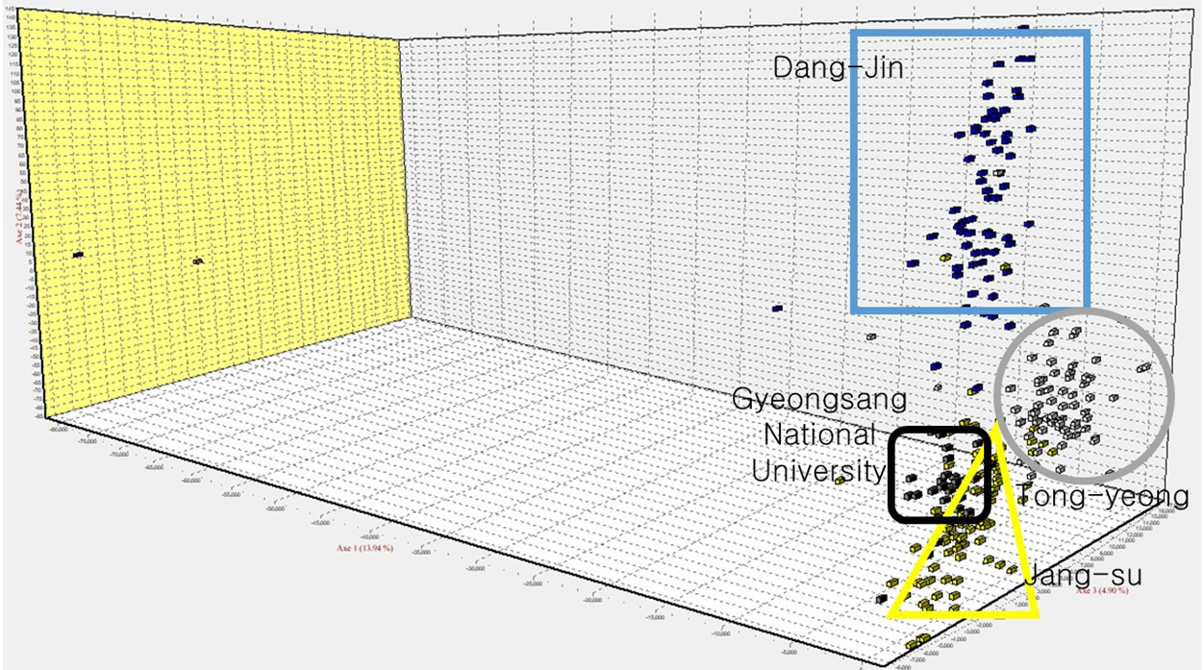

Fig. 1. Results of FCA analysis. This plot shows a tendency to cluster by each line.

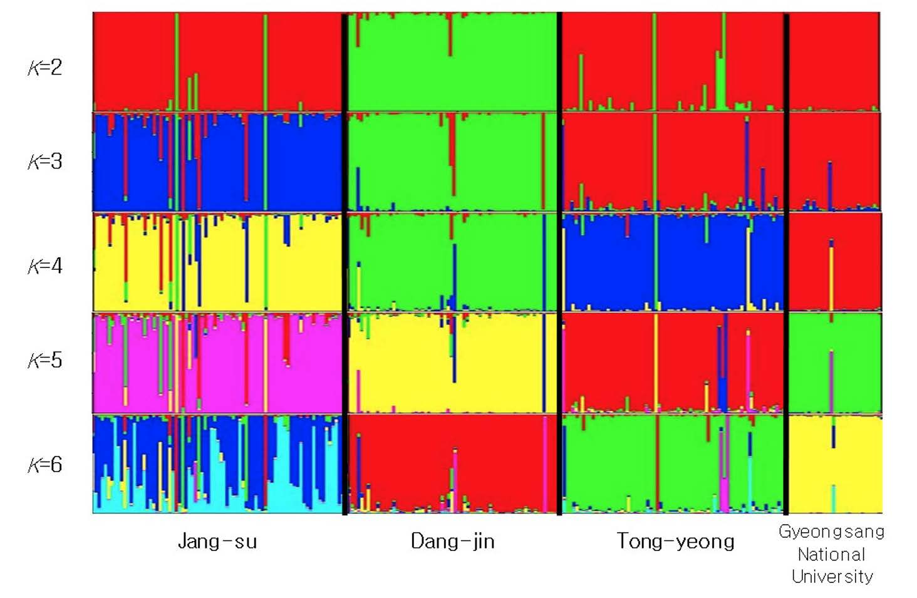

Fig. 2. This is result of the analysis of the STRUCTURE 2.3.4 program. The optimal value of *K* is 4, and each line shows an independent genetic structure.